SOFTWARE REQUIREMENTS SPECIFICATION SAMPLE DOCUMENT

OrangeHRM – PIM Module

Add Employee – personal details feature

Project Functional Requirement Specification, Version 3.3

**06nd of June 2022**

**PIM Module**

**PIM Module** is an important tool that maintains all relevant employee related information, including different types of personal information, detailed qualifications, work experience, job related information etc. etc. Information captured in this module is utilized by all other modules, thus eliminating data redundancy. Records can be either entered manually one by one or imported from a CSV file. You cannot import all the details but you can edit the remaining fields.

The functionality of the PIM Module differs depending on the rights of the user.

The HR can:

* Configure optional/custom fields, data import from CSV, define reporting methods and termination reasons that will be used throughout the module.
* View all employee details
* Add employee on the list.
* Generate employee report

ESS-Supervisor can:

* View his personal details as well as his/her subordinates.

ESS-Employee:

* Has no access to the PIM module but can view his personal details under the ‘My Info’ Module.

The area that I chose to use for this project is “Add employee – Personal details”.

**Add Employee**

To add a new employee, click to PIM>>Add Employee. A new employee is added to the system here. Other than importing details this feature allows to add an employee and define a very informative profile. (See figure 1.1)

**Figure 1.1**

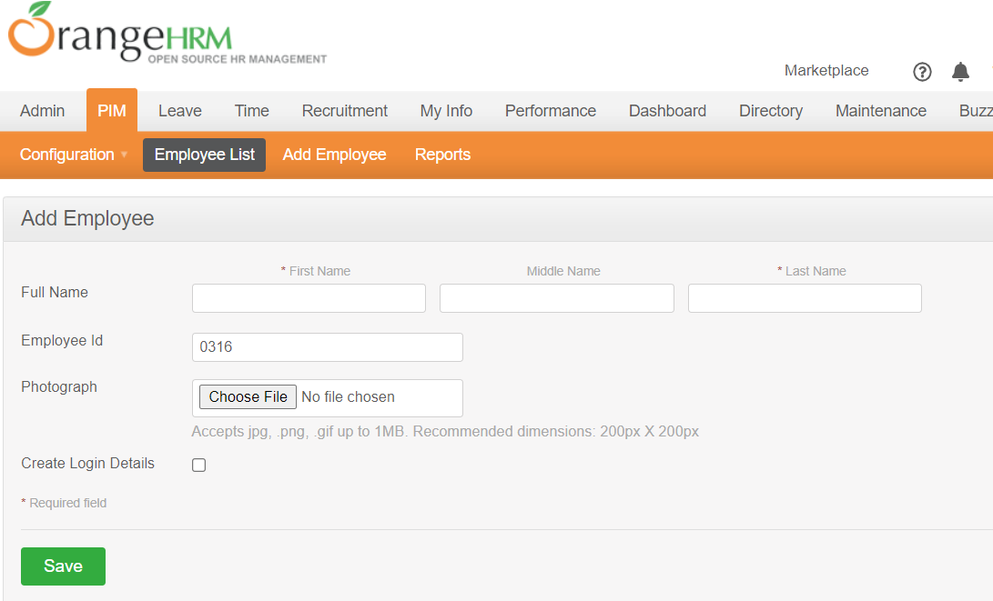

The form will contain:

* First Name – mandatory field – text type – max 30 characters. When max is reached user cannot be saved
* Last Name – mandatory field – text type – max 30 characters. When max is reached user cannot be saved
* Employee id – auto complete according with SQL database.

Click “Save” once all mandatory fields are entered and a page with multiple entries will appear. (See figure 1.2):

* **Personal Details**;
* Contact Details;
* Emergency Contacts;
* Dependents;
* Immigration;
* Job;
* Salary;
* Tax Exemptions;
* Report-to;
* Qualifications;
* Membership.

**Figure 1.2**

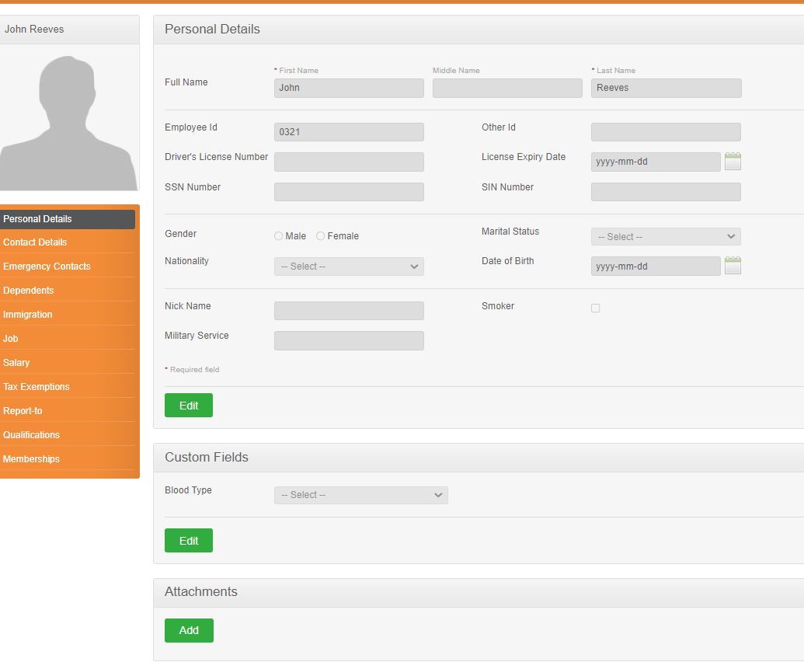

**Employee’s Personal Details**

The following information needs to be obtained from each employee to create a complete employee profile that may be used by the company. These features are explained in details as we go on.

One you have added and saved the employee’s name with his/her picture and the user logins; the screen as shown in Figure 1.3 will appear. You can also edit the personal details listed below by clicking “Edit” on the bottom of the screen. Clicks “save” once the fields are added.

**Figure 1.3**



The form will contain:

* Code Employee Id/No – autocomplete - optional field – varchar (10) type;
* Last Name mandatory field – text type – max 30 characters. When max is reached user cannot be saved
* First Name - mandatory field – text type – max 30 characters. When max is reached user cannot be saved
* Middle Name - optional field - text type – max 30 characters. When max is reached user cannot be saved;
* Nick Name - optional field - text type – max 30 characters. When max is reached user cannot be saved;
* Nationality – optional field - Select from a drop-down list of pre-defined;
* Date of Birth - optional field – date type – value cannot be in future;
* Other Id - optional field – integer type;
* Marital Status –- optional field- select from the drop-down list:
  + Single,
  + Married,
  + Other;
* Smoker – optional field - if the employee is a smoker click on the box;
* Gender – optional field - click on the relevant gender;
* Driver’s License Number – optional field – varchar (20) type;
* License Expiry Date - optional field – date type – value cannot be in the past;
* Military Service – optional field – varchar (30) type;

Click “Save” once at least all the mandatory fields are entered (see figure 1.4).

**Figure 1.4**

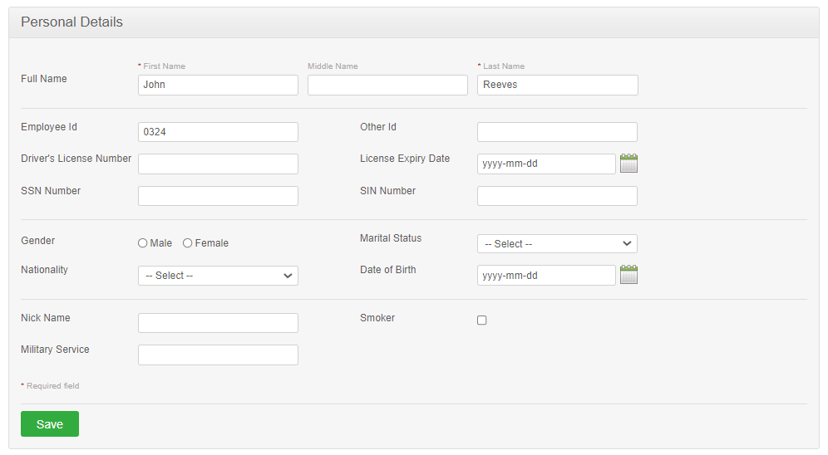

**Custom field**

This feature allows the admin to customize the new employee personal information and add a new field with the blood type. To add, go to PIM>>Add new employee>> Complete mandatory fields>> click “Save”>> click “Edit” in Custom Fields and the screen as shown in Figure 1.5 will appear.

**Figure 1.5**

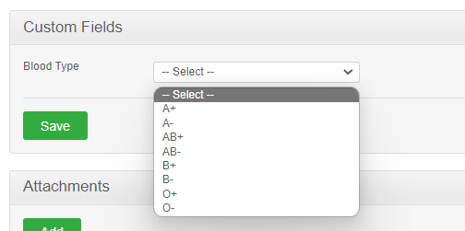

The form will contain:

* Blood Type – optional field - Select from a drop-down list of pre-defined;
  + A+
  + A-
  + AB+
  + AB-
  + B+
  + B-
  + 0+
  + 0-

Click “Save” once you have entered the details and the fields defined for blood type will then be added.

**Add attachment**

You may also upload any attachment that would support the details you have entered on the form by clicking “Add” under the “Attachment” and selecting a file from a relevant path and upload the following file by clicking “Upload” as shown in Figure 1.5. Please note that each document is maxim 1 megabyte.

**Figure 1.5**

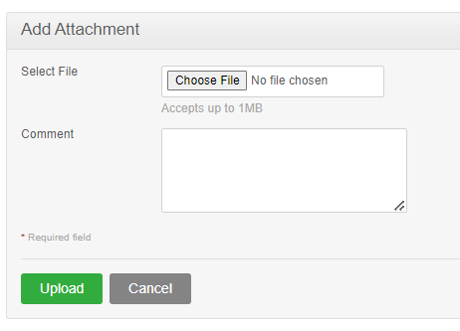

Once you have uploaded the file, the file will be listed as shown in Figure 1.6.

**Figure 1.6**

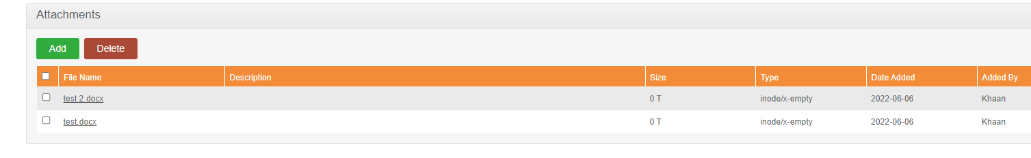

You can upload multiple entries of supporting attachments. You can edit the following attachments by clicking “Edit” on the right side of an entry as shown in Figure 1.7.

**Figure 1.7**

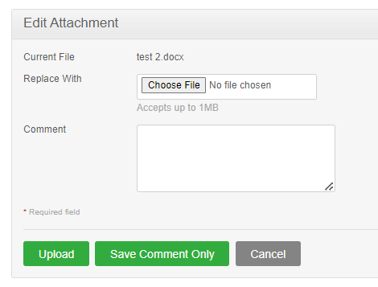

Attachments can be edited using Edit option. In edit mode will be visible:

* The current File – non editable field
* Replace With – choose file field type
* Comment – optional field- string type , max 200 characters permitted.

In edit mode 3 buttons are available:

* Upload
* Save comment Only
* Cancel

To delete an attachment, click on the check box next to particular entry. It is also possible to delete multiple entries at the same time by clicking the check box entries you wish to delete and simply clicking “Delete” ( figure 1.7).

Figure 1.8

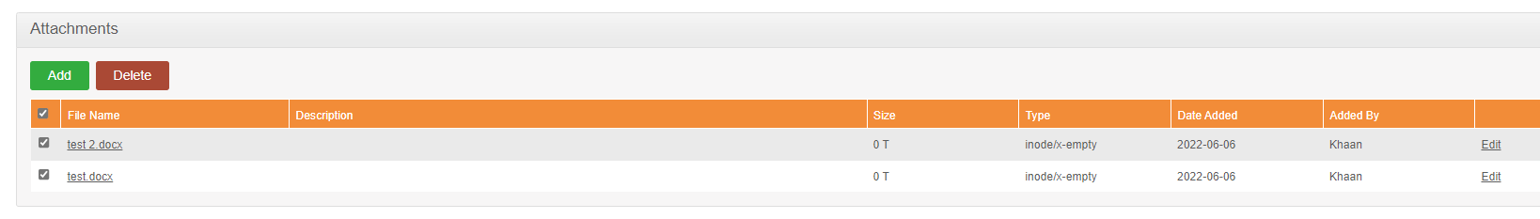

# Sign-Off Document

The following parties have read and agree with this Requirements Definition document for the OrangeHRM application account module functionality.

After approval of this Requirements Definition phase, any significant changes in the scope of this project will require validation of existing project costs and schedules.

______________________________________ _________________________________

Name Date

Business Lead

______________________________________ ________________________________

Name Date

Project Manager